Careers and Placements Sustainability Statement 2023/4

Careers and Placements, through the Green Impact environmental programme, has a Green Careers team to encourage everyone in Careers to be more environmentally aware and reduce our carbon footprint.

In 2024 we will aim to gain the Green Impact Gold level award, at the very least, submitting evidence of our efforts towards environmental and sustainable status. Guided by the University’s Sustainability Plan and the UN’s Sustainable Development Goals (the three below, in particular).
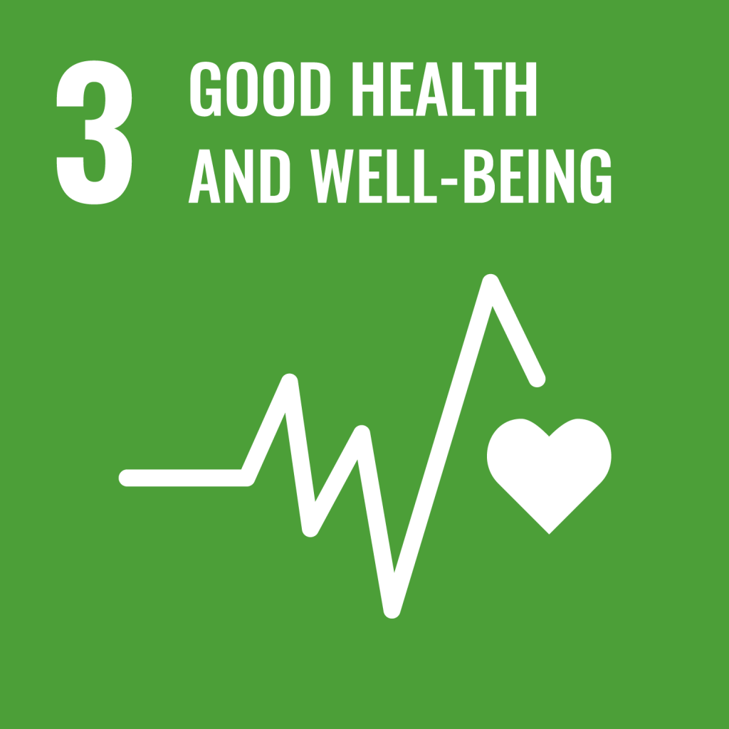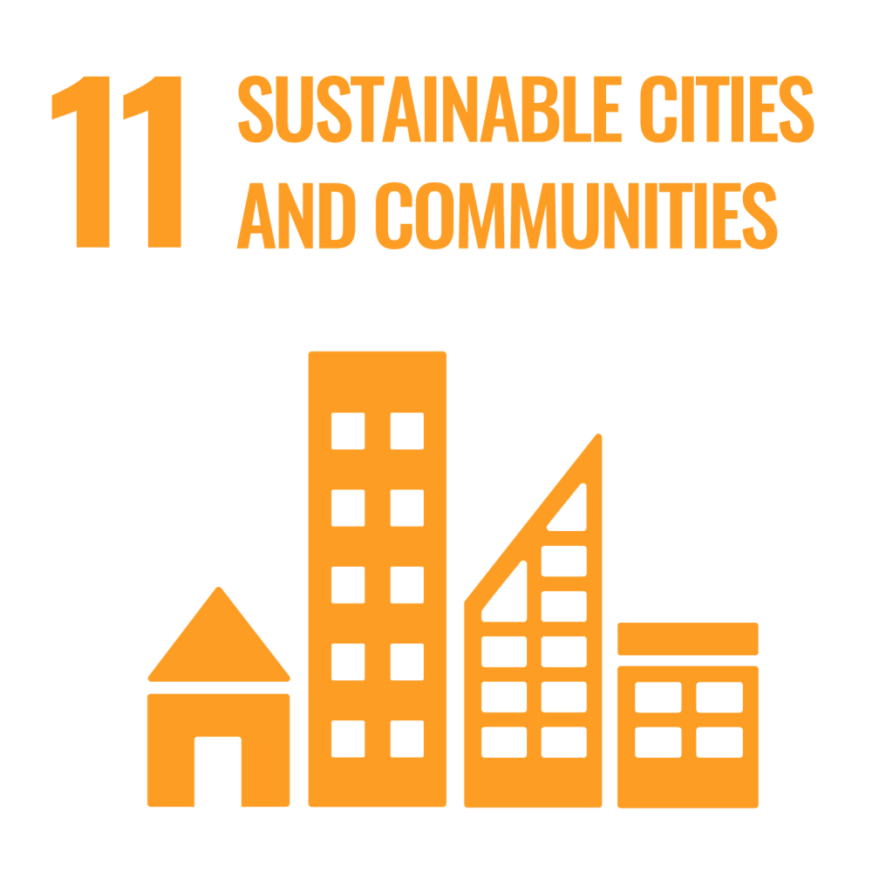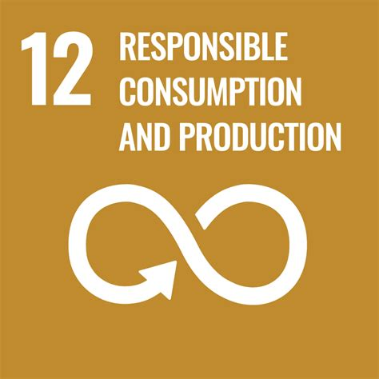
Among positive actions taken, we:

- actively encourage recycling to avoid waste and to reduce the impact on the environment by having various recycling bins throughout the Careers Building. We have also removed individual waste bins in offices to encourage the disposal of items in appropriate bins (and particularly recycling bins)

- endeavour to educate all staff to acknowledge the contribution they can make in saving energy such as turning off lights, computers, monitors and switching off the kitchen electrical equipment at the plug, when not in use

- organise charity events, such as the Macmillan coffee mornings, Save the Children Christmas jumper day, the Great British Bake Off Challenge, alternative Christmas card collection for a different charity each year, Sport Relief cake sale, toilet twinning, etc

- encourage staff to think before they print and to not take paper handouts to presentations, but to refer students to web links. We re-use paper as scrap paper that has been printed in error and have reduced the number of publications both in-house produced and career publisher-provided

- encourage staff to bring in unwanted, but reusable items from home to offer to others. In addition, staff are encouraged to use the University’s recycle slack channel to reuse items

